Esther Dialogue
Monologue when drug level goes up/down within game
Trivia drugs (3)
General/Instructions to play
The objective of the game is to prevent yourself from succumbing to the temptations/threat of drugs! Bad neurons contain electrical impulses. When networked, they form strong thoughts and might cause you to succumb to taking drugs. You can prevent “bad neurons” from forming by clicking on the connections in time to prevent them from forming successfully. Challenge yourself to remain strong minded by resisting drugs by removing all connections from forming!
Scroll around your big brain!
Appearance
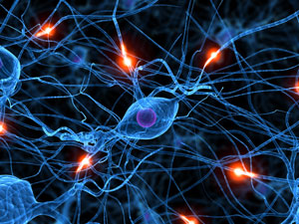
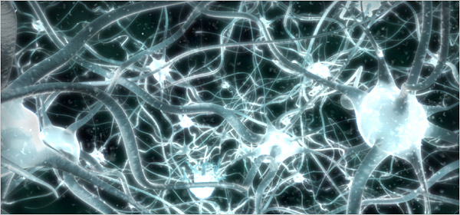
Neurons should be looking like these star-shaped structures. Something cleaner though. Background should have these things as silhouettes in the faded background. Clean. The focus should be on the neuron impulses.
Map size
The map size is 2048 by 1536. This allows the user to scroll by 1 screen length and height.

Mechanics
We want the each “battle”/simluation to last for about 3mins. Neuron impulses form and float around the map at a speed of 10pixels/s. When they hit the walls when they bounce in the opposite direction.

Bad neurons are glowing red. They appear and form at rate of When neurons are 100px apart, they form connections (play bond animation) when bond animation finishes the bond is completed and faded to glowing red silhouette.

There will be “good neurons” such as thoughts of family and sports and friends. When clicked on, they release

If player loses game, his health bar(bottom left corner deteriorates
1 - Glue Sniff @ Carpark
When neuron number exceeds 15, conscience dialogue box reads “Nooooooo! I’VE GOT TO FIGHT THE FEAR! I CAN’T LIVE A LIFE OF DRUGS!”
When neuron number <15, conscience dialogue box reads “Yes that’s right! Life does not rewind! I’ve got to fight it!”
When neuron number <5, message reads “NEVER DRUGS NEVER!!!”

